**Find current IP Address of computer**

**Ipconfig command**

Ipconfig command is used to find the IP configuration of the computer.

1. Press Windows + R keys together
2. Type ‘cmd’ and click OK

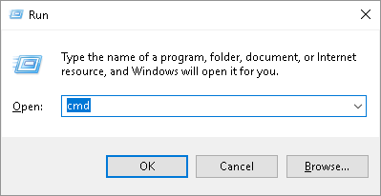

1. Type ‘ipconfig’ and press Enter

IP parameters of wifi.

Parameters are not showing, then Wifi is not connected

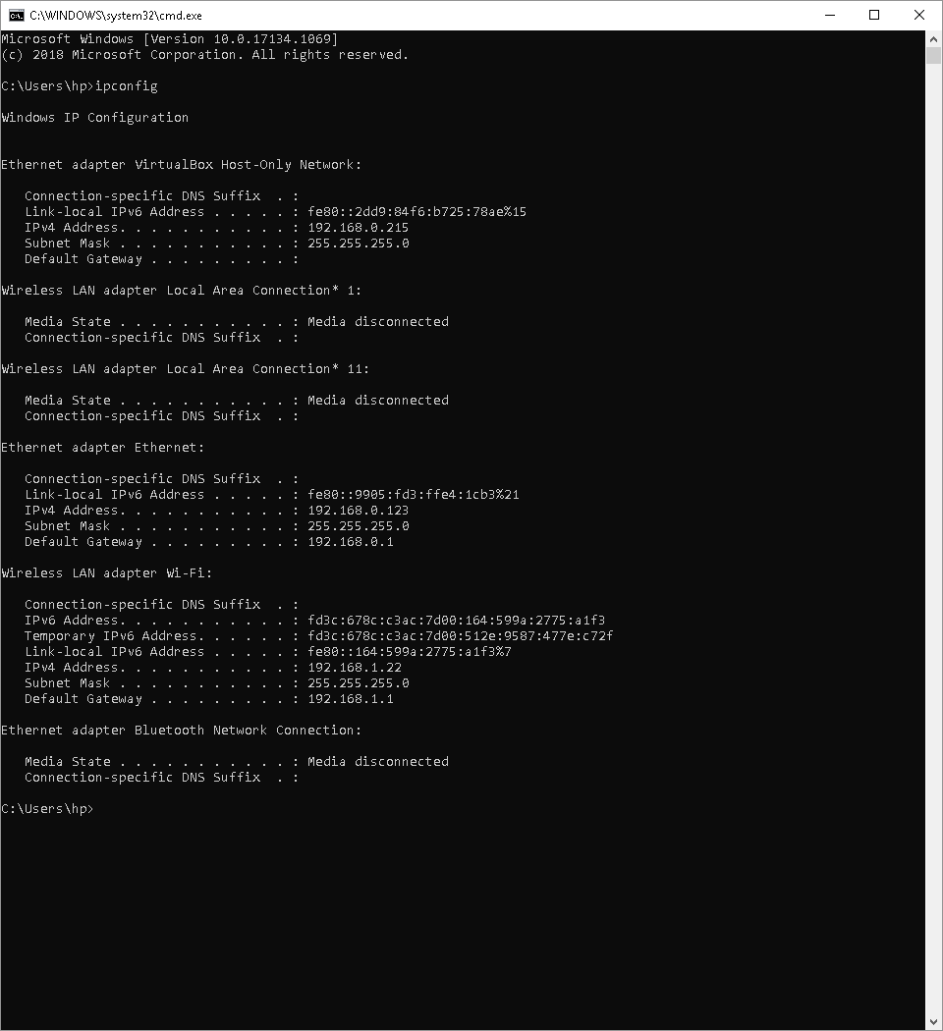

IP parameters of wired LAN (Ethernet).

Parameters are not showing, then LAN is not connected

**To change IP Address of PC:**

1. Click **Start Menu** > **Control Panel** > **Network and Sharing Center** (For Windows 8 and higher, search for and open Control Panel and select Network and Internet).
2. Click **Change adapter settings.**
3. Right click on **Local Area Connection** and click on **Properties.**
4. Select **Internet Protocol Version 4 (TCP/IPv4)** and click on **Properties**.
5. Select "**Use the following IP address**" and enter the IP address, subnet mask, default gateway and DNS server. Click **OK** and close the Local Area Connection properties window.

**Default Settings (If not given any IP by user, then set this IP)**

IP Address: 192.168.0.123

Subnet Mask: 255.255.255.0

Gateway: 192.168.0.1